Revenue Reduction Calculation
- From the QBO – Navigation tab.

  - Go to “Reports”
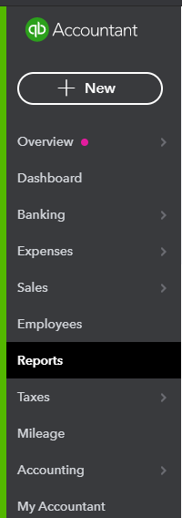

  - Select “Profit or Loss”
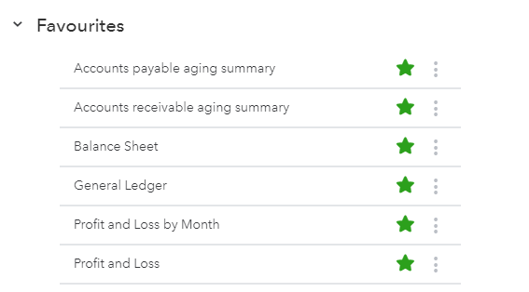

- From the “Profit or Loss” reports:

  - Find your Eligible Period Revenue:
    - Select the applicable report period:
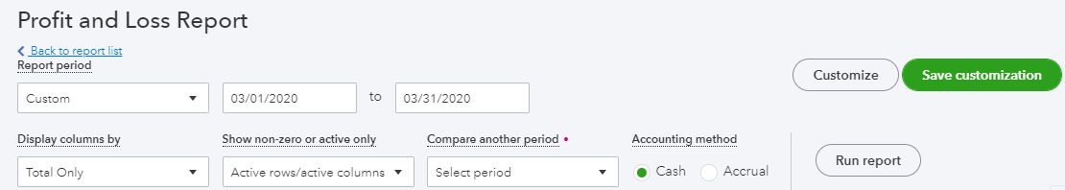
      - Under “Report Period”, select “Custom” and enter: March 1, 2020 to March 31, 2020 as show above.

  - Baseline revenue reduction determination:

There are two ways of determining the baseline revenue reduction eligibility. Using a 1-month comparative method (ie: March 2019 compared against March 2020); or the average method (average of January 2020 and February 2020 compared against the March 2020). Please note that the baseline selected must be used for the duration of the CEWS program – ie. You cannot compare March 2020 figures to March 2019, then April 2020 figures to the average of January 2020 and February 2020. If you selected 2019 as your comparison year, that must continue for future periods.

    - For the “1-month comparative”, follow the instructions below:
      - Under the “Compare another period, select “Previous period” as shown below.
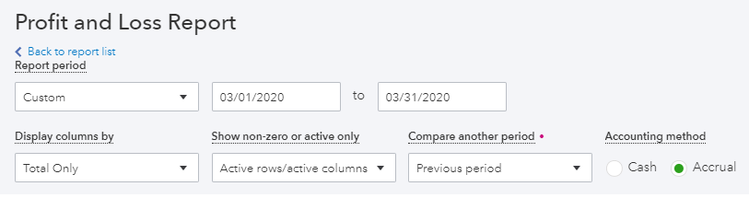
        - Under the “Custom period” field, enter: March 1, 2019 to March 31, 2019, as shown below.
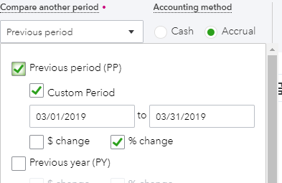
        - Turn on “% change” to view the reduction.

        - For the accounting method, select “Accrual”.

        - Select “Run report” to finish.

      - Repeat the steps for “Cash” accounting method as well to see which method of accounting is more applicable for the revenue reduction.

      - Once you determine a method for the eligible revenue reduction (ie. cash or accrual), you cannot swap to the other accounting method for future periods.

    - To see if you are eligible for the average method (ie: average revenue for January 2020 and February 2020 compared against March 2020), follow the instructions below:

      - Under the “Report period”, select “Custom”, enter: January 1, 2020 to March 31, 2020, as shown below.
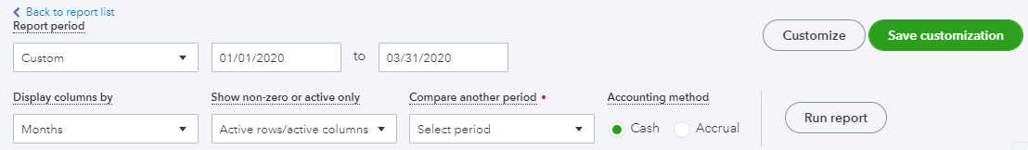

        - Under “Display columns by”, select: “Months”

        - Run report.

      - This should give you a month to month comparative from the period January 2020 to March 2020.

      - Calculate the average for the months of January 2020 and February 2020 to compare against the March 2020 revenue to determine if the eligible revenue reduction criteria are met.

      - Repeat steps under the “Accrual” accounting method as well.

          - Like the 1-month comparative method mentioned previously, determine if the “cash method” or “accrual method” for accounting is more applicable for you. Once the method is selected, you cannot change back.

    - For either method above, we have provided a template, see attached “CEWS – Template” to help with the calculations.

